Reservasi Konsultasi Dokter (Resuldok) System

in Satusehat

Muhammad Irfan*1, Fadgham Albar Ronggoputra*2, Fidzal Adrian*3, Rama Banin Maula*4, Raditya Rifan Zaidan*5

*\*Faculty of Mathematics and Natural Sciences, Universitas Gadjah Mada*

*Sekip Utara Bulaksumur 21, Sendowo Sinduadi, Mlati, Sleman, Daerah Istimewa Yogyakarta*

*Indonesia*

[1](mailto:1first.author@first-third.edu)muhammad.irfan2503@mail.ugm.ac.id

2[fadgham.albar190](mailto:1first.author@first-third.edu)4@mail.ugm.ac.id

3fidzal.adr2003[@](mailto:1first.author@first-third.edu)mail.ugm.ac.id

4rama.banin.maula@mail.ugm.ac.id

5raditya.rifan.zaidan@mail.ugm.ac.id

***Abstract*— Satusehat is a Ministry of Health Republic of Indonesia’s program that provides access to healthcare services and information. Innovation in program’s developments are essential to support Indonesia’s healthcare transformation in infrastructure for the digital era. One of many innovations is allowing patients to make phone-in reservations for a doctor appointment, while electronic medical records are kept well in integrated systems and updated periodically in Satusehat.**

***Keywords***— **Reservation, Satusehat, Event-Driven, Integrated, Health Instances**

1. Introduction

Majority of Indonesia's healthcare reservation system is still using the traditional queueing on the spot for registration. Thus, a problem appeared about the reservation system. What needed to be addressed is how would patients make an appointment with a doctor without waiting on a line the same as other new patients that need to register first. The problem orbited around time and identified that healthcare needs to make appointments efficiently without taking a long time to queue. especially, registered patients in the same health instances or their medical record is integrated in Satusehat.

Satusehat offers an integrated system of electronic medical records (EMR) kept in health instances so patients could see their record in one interface. Because of this, health instances need not to write medical records only for one patient. We developed the system so that it could be used as patients could move from one health instance to another instance when they need it.

We make it similar to another feature in Satusehat called SIRANAP 3.0 that allows patients to book a room in health instances. What differs our innovation is, Resuldok allows patients to choose who, when, and where the consultation will be done. Also, only made to patients that had registered in the Satusehat integrated system. This feature is expected to increase the productivity and efficiency in Indonesia’s healthcare services.

1. Methods

Our chosen method is Android based software as an approach in Satusehat system development which has so many features and can be useful for both patients and doctors, another reason we chose this method is the popularity and android capacity as a platform used widely in Indonesia. It can integrate components and services that are needed in our proposed innovation for reservation system. procedures in developing in Resuldok includes Problem selection and analysis, architecture design, interface design, data design, and component design.

1. *Architecture Design*

Architecture design used in Resuldok is Event-Driven (EDA) that mainly focuses on events in the system and responses that are given. In the context of Resuldok, an event happened when a user made a reservation for consultation and the system responded by giving the user success note and doctor notification. The EDA ensures components communication is done asynchronously and distributed, allowing the system to quickly respond to any changes surrounding the event.

1. *User Interface Design*

Resuldok interface designed using figma, it gives options for building new assets and design visualization using provided components. We tried to match the Satusehat color palette to bring consistency and give user recognition, so users can navigate through the interface intuitively. Interface should be designed for the user to search for a doctor, available schedule, and health instance with minimum effort.

1. *Data Design*

Data design in Resuldok uses MySQL Workbench. to get database visuals we used reverse engineering from MySQL tools. The Data design includes Structured tables such as Patients, Doctors, Ministry of Health Republic Indonesia, Schedule, Reservation, Medical Records, and Health instances. Information such as Patient record, Doctor records, Health Instances address all included in the database. Each table has a relationship one to another to keep consistency and data integrity.

1. *Component Design*

Component design in the Resuldok system involves functionality implementations that are needed to make the system perform. a number of the main components needed are user component, doctor component, schedule component, and reservation component. These components interact with each other and the database, to ensure the process executed well. The components implementation needs to be aware of business logic and datastream for Satusehat and Resuldok systems.

1. Results

Results from this software development is a new feature for Satusehat application to allow users to reserve an appointment with a doctor without queueing on the spot for reservation. Patients who have registered their medical records in Satusehat can select the location of the hospital and then search for the desired doctor according to the corresponding department..

1. *Pain Points*

We identified some pain points along the development of Satusehat’s feature Resuldok. One of them is how we select the issue that relates to our everyday lives and would be useful to other patients in using the Satusehat application. At first we list a number of innovations that can be implemented in the near future without taking into consideration real life problems that happened before. After combining our thoughts in selecting the issue, we analyze what would be the most urgent to solve first is the reservation or appointment system in Indonesia that had not been so efficient for patients that already registered their medical record. Thus, we offered a solution by adding a feature to the Satusehat application to provide phone-in reservation for patients.

1. *Proposed Design*

Our proposed design includes architecture design, user interface design, data design, and component design.

Architecture design used is event-driven architecture (EDA). The event will be prompted by patients and the response will be a success note for patients and notification for the doctor. there will be responses from database to system server and system server to Satusehat application shown in Figure 1.

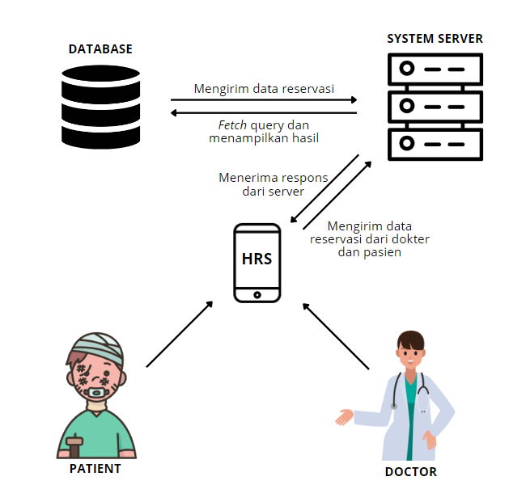

Figure. 1 Event-Driven Architecture of Resuldok

User interface design for Reservasi Konsultasi Dokter (Resuldok) using provided resources and assets from figma and matching with Satusehat design shown in Figure 2.

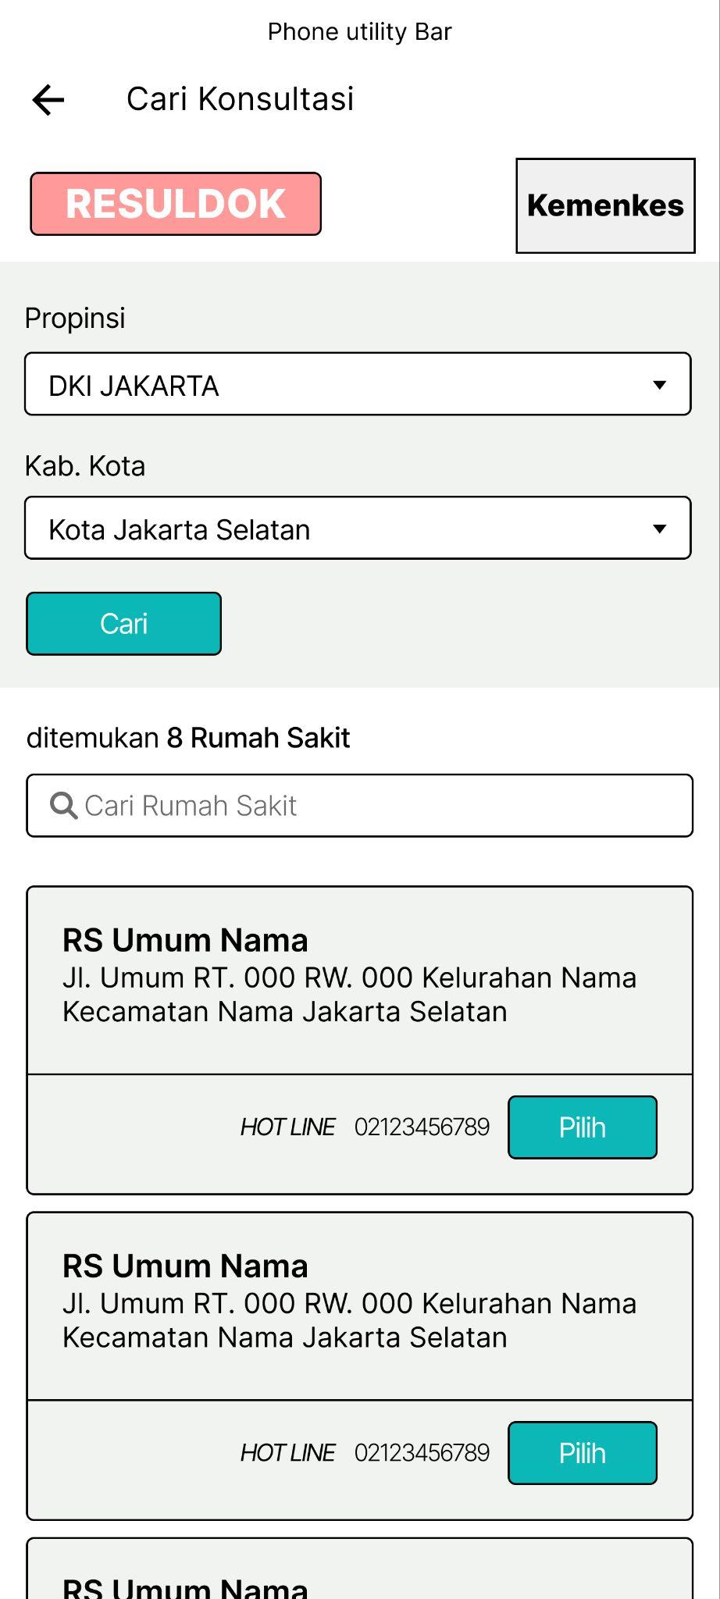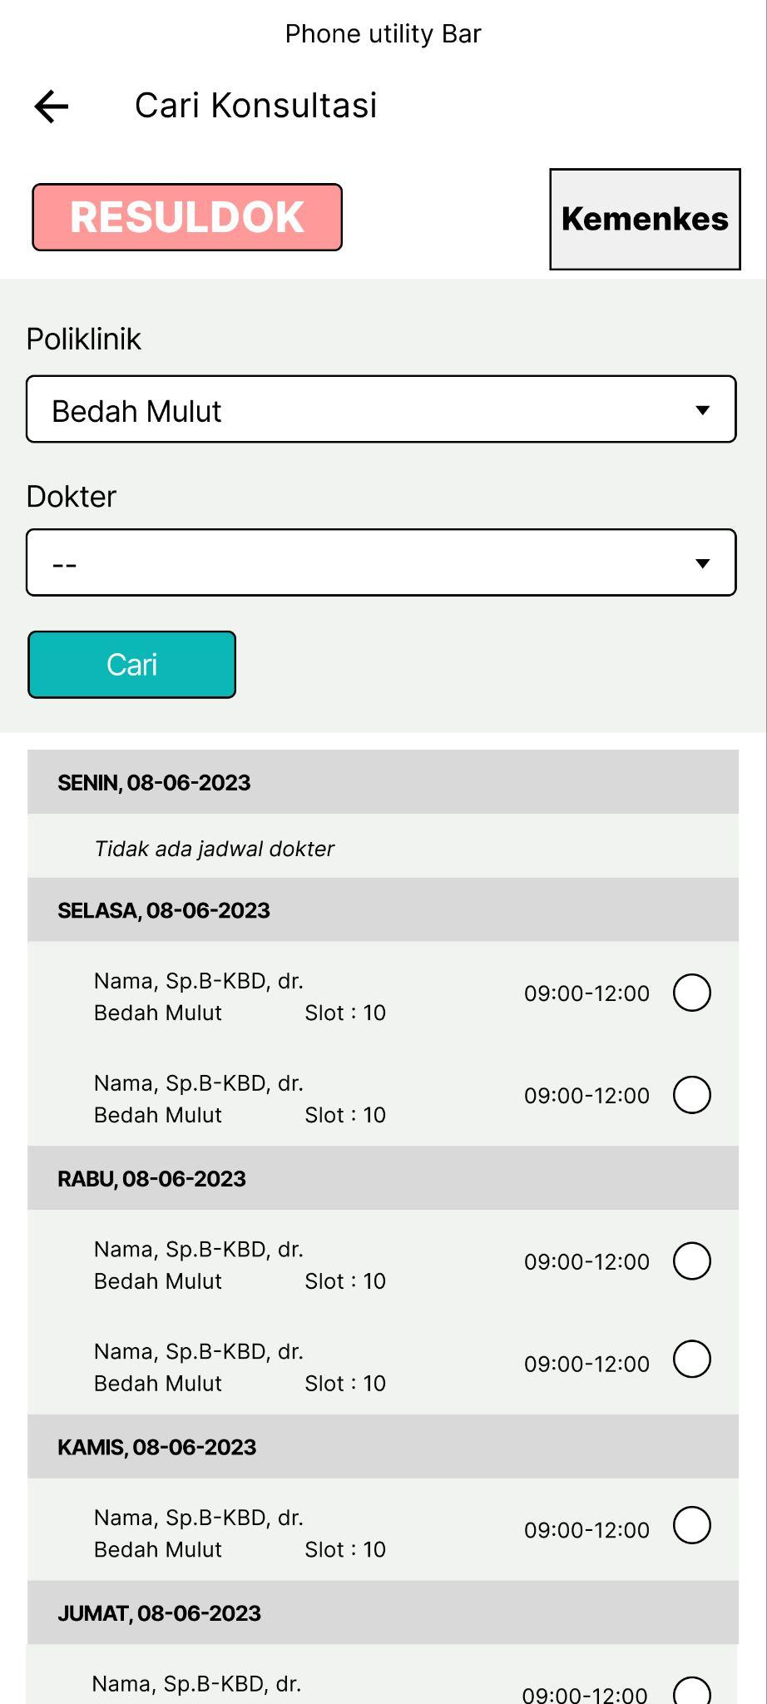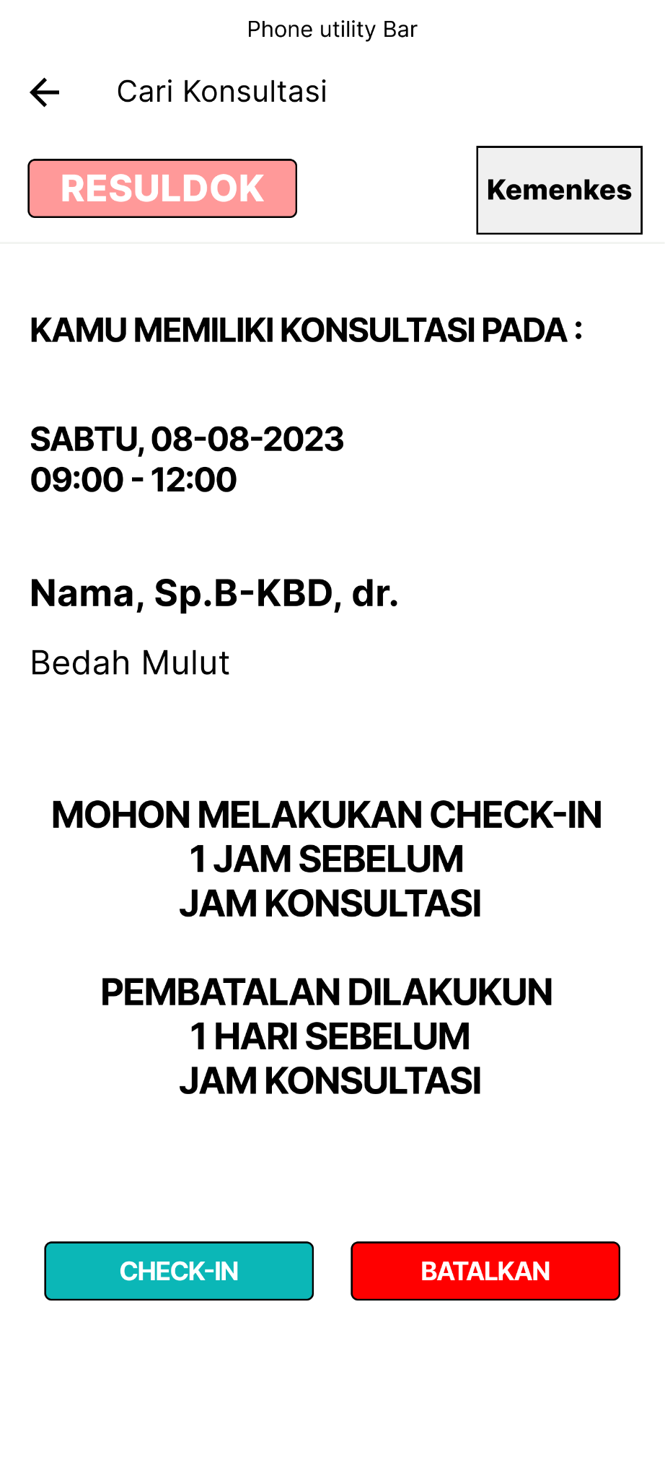

Figure.2 User Interface Design of Resuldok

Data design consists of tables such as patients, doctors, ministry of health, health instances, reservation, schedule, and medical record with their relationship to other tables shown in Figure 3.

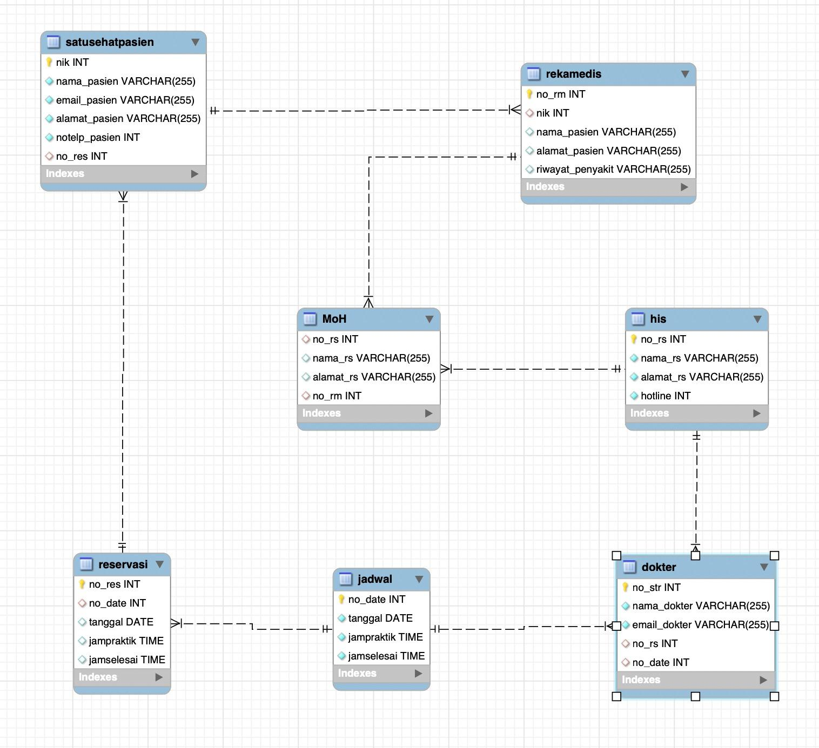

Figure.3 Data Design of Resuldok

Component design visualizes components in this feature consisting of User, Doctor and Health instances, schedule management, and Reservation as shown in Figure 4.

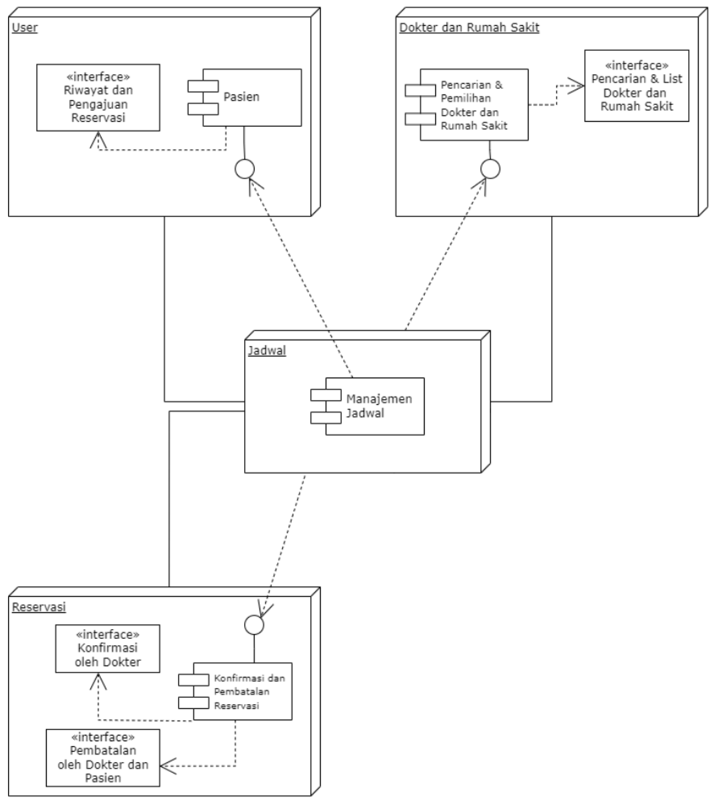

Figure.4 Component Design of Resuldok

Our proposed design fits into the Satusehat application even when there are some new components made, it does not change the Satusehat application significantly.

This feature is similar to SIRANAP 3.0, one of Satusehat’s features where it can search the location of health instances and room types. We implemented Resuldok as close to SIRANAP 3.0 to give recognition to users that had used this feature.

1. Disscussion

The design proposed for Satusehat android application development is represented by four design that will be used for reference in implementing Resuldok feature.

Resuldok will be accessable from the home or dashboard page of Satusehat. There will be an icon directing user into Resuldok page to make a reservation.

When a user already accessed Resuldok from the dashboard, the user will be instructed to search desired health instances through city and province. There will be a list of health instances with a hotline number and address on the page. The user chooses one health instance then is instructed to filter the department and the doctor name that they want to make a reservation with. If the user has not prompted any filter on the location search page and doctor search page then there will appear a sign telling that the user has not filtered or chosen anything to begin the searching.

Although this development only on application aspects, it does not close out any opportunities to integrate this system with Satusehat’s Website or Ministry of Health Republic Indonesia.

1. Future Works

After gaining an understanding of the challenges faced by the Satusehat platform and proposing an application feature design for the platform, a number of future works could be possible focus for Satusehat in the near future:

1. *Telemedicine* System Development

On Satusehat mobile app it is possible to develop a telemedicine system for patients. With this feature, patients could consult with a doctor through an online video conference. This feature will ease access to patients surrounding health needs without being able to go to health instances.

2. Integrate more health instances

More integration means more resources and access to patients all over Indonesia. Satusehat will gain access including appointment schedule, inpatient room, and other facilities in every health instance. This integration is intended to increase data availability and information accuracy.

3. Billing system

Applying Billing system on integrated Satusehat will ease the administration needed for patients. Billing can be made online which corresponds to the telemedicine system.

4. *Emergency Response* Feature

One of the most critical aspects in healthcare is an emergency situation, with this feature developed users will be able to access a health instance’s hotline number, first aid instructions, or calling an ambulance. This development will also reduce the risk of death due to delayed treatment from the nearest health instance.

References

1. T. E. Kwadwo, K. Kusi, and P. A. Rutherford, *Design and Implementation of Hospital Reservation System on Android*, *IJCSIS,* Vol.17, No. 10, October 2019.
2. Obulor R., Eke B. O., *Outpatient Queueing Model Development for Hospital Appointment System*, IJSEAS, Vol. 2, Issue 4, April 2016
3. L. Heryawan, Y. Mori, G. Yamamoto, L. Lazuardi, A. Fuad, and T. Kuroda, “FHIR-based Interoperability Design in Indonesia, JASSO, *Follow-up research,* April 2023*.*
4. Wilson D., Sheikh A., Gorgens M., and Ward K., Technology and Universal Health Coverage: Examining the role of digital health, JOGH,16006, November 2021.
5. B. M. Michelson, Event-Driven Architecture Overview, Patricia Seybold Group Research Service, February 2011.
6. I. Sommerville, "Software Engineering," Pearson Education Limited, 2016.
7. L. Bass, P. Clements, and R. Kazman, "Software Architecture in Practice," Addison-Wesley Professional, 2013.
8. A. Cooper, R. Reimann, and D. Cronin, "About Face 3: The Essentials of Interaction Design," Wiley, 2007.
9. M. A. Hoffer-Hawlik, A. E. Moran, D. Burka, P. Kaur, J. Cai, T. R. Frieden, dan R. Gupta, "Leveraging telemedicine for chronic disease management in low- And middle-income countries during Covid-19," Global Heart, vol. 15, no. 1, 2020.
10. M. A. Pratiwi, F. Lestari, dan Ridwansyah, "Analisis Implementasi Sistem Tanggap Darurat Berdasarkan Asosiasi Perlindungan Kebakaran Nasional 1600," Kesmas: Jurnal Kesehatan Masyarakat Nasional, vol. 7, no. 10, pp. 435–439, 2013.
11. R. K. Novriantama, A. Kusyanti, dan R. I. Rokhmawati, "Analisis Privasi dan Kepercayaan Terhadap Keamanan Data Pengguna Aplikasi On Demand Service Menggunakan Metodologi Structural Equation Modeling," Jurnal Pengembangan Teknologi Informasi Dan Ilmu Komputer, vol. 2, no. 3, pp. 1161–1169, 2017.